**NATIONAL UNIVERSITY OF SINGAPORE**

**Department of Electrical and Computer Engineering**

**AY 2021-22**

**EE4502 Project-Based Lab Experiments**

**Exp 2: AC Drive Systems**

***Main objective:***

The main objective of this part of the experiment is to study AC variable speed drive (VSD) system. The AC VSD drive system consists of a three-phase bridge rectifier (AC-DC), inverter (DC-AC) and AC motor (asynchronous). In the diode bridge rectifier stage, fixed voltage and fixed frequency three-phase AC power source is rectified into unregulated DC power source. Through the PWM inverter, the unregulated DC power source is converted back into variable voltage and variable frequency regulated three-phase AC power source to drive an AC induction motor. The AC Drive system controls speed and torque of the AC motor by adjusting the voltage and frequency supplied to the motor in a coordinated way. There are two different types of control modes to be discussed in the experiment namely *open-loop* and *closed-loop* *v/f* control of the induction motor. For each mode, the dynamic and steady-state performances of the drive system will be investigated.

**Discussions**

**Discussion 1: Introduction to DC-to-AC Conversion using pulse width modulation (PWM) inverter**



Figure.1: Circuit diagram of PWM inverter

Three phase PWM inverter can be used to obtain a high-power controllable AC voltage and frequency with high efficiency from a DC voltage by controlling the IGBT semiconductor switches ON and OFF operations. The circuit diagram of a three phase PWM inverter is shown as Figure.1.

Figure. 2 gives the idea of how to generate the AC voltage source by controlling the IGBTs operation. In Figure.2, the IGBTs act as switches which close and open in turn. The output voltage (Vo) equals +Vdc/2 when Q1 is closed and Q2 is opened and the output voltage is –Vdc/2 when Q1 is open and Q2 is closed, as shown in Figure.2.



**AC voltage**

**DC voltage**

Figure.2: AC voltage source generation

However, the waveform of the output voltage is not sinusoidal; rather it is a rectangular wave whose amplitude varies from +Vdc/2 to –Vdc/2 and whose pulse width varies in accordance with the signals which control the switching of the IGBTs. By filtering and modulating the duration of these pulses at the output of an inverter, it is possible to obtain an output waveform that is close to sinusoidal shape. The modulation of the pulse duration is called *pulse-width-modulation* (PWM). It is therefore possible to obtain a sinusoidal waveform by sinusoidally varying the duty cycle of the IGBT control signals. The frequency of the control signal is the same as the output AC voltage *frequency*, and the frequency at which the duty cycle varies, is called the *carrier frequency*.

**Discussion 2: Introduction to *v/f* Control of Squirrel-Cage Induction Motor**

A three-phase squirrel-cage induction motor can be represented by three transformers whose primaries correspond to the three phase stator windings, and whose secondary windings correspond to the three phase rotor windings. It is thus possible to determine the behavior of a motor by using a circuit similar to that of the transformer shown in Figure 3.



Figure.3: Per-phase equivalent circuit of a squirrel-cage induction motor

The circuit shown in Figure.3 allows accurate prediction of the behavior of a squirrel-cage motor for various operating conditions. Stator resistance, *Rs* corresponds to the resistance of the stator winding, and leakage-inductance, *Ls* corresponds to the leakage inductance produced by the flux flowing in the stator winding but which does not flow in the rotor winding. Magtetizing inductance, *Lm* corresponds to the inductance produced by the flux flowing in the stator winding as well as in the rotor winding. The core resistance, *Rm* corresponds to iron/core losses component and its value depends on the source frequency. The rotor resistance, *Rr* corresponds to the resistance of the rotor winding, and leakage-inductance, *Lr* corresponds to the leakage inductance produced by the flux flowing in the rotor winding but which does not flow in the stator winding.

The other resistance shown in the circuit is a variable rotor resistance, *Rr(1-s)/s*. It represents the mechanical load applied to the rotor and depends on the slip of the motor. The equivalent circuit of the motor is thus similar to that of a transformer to which a resistance is added at the secondary to represent the mechanical power delivered by the rotor. Once the circuit equations are solved, the power dissipated by resistor *Rr(1-s)/s* is determined and the power dissipated across this variable rotor resistance indicates the electrical power converted into mechanical power. Because the mechanical power is the product of the torque and speed, it is possible to determine the torque value for each speed of rotation. When the rotor speed equals the synchronous speed (*s* = 0), the value of resistor *Rr(1-s)/s* is infinite. The current flowing in the resistance is null and no power is delivered to the mechanical load. When the rotor speed becomes lower than the synchronous speed, the resistance value of *Rr* decreases, and current flows through the resistor. The power dissipated by the resistor corresponds to the torque produced by the motor.

In order to build a powerful motor which is able to develop high torque, the strength of the magnetic field of the stator has to be increased. In the meantime, the magnetic flux cannot be increased too much so that the iron begins to saturate. Therefore, the operating point of magnetic flux should be kept at optimal point i.e. at the knee point of the magnetic saturation curve. The magnetic flux depends on the current flowing through the magnetizing inductance, *Lm*. To maintain the magnetic flux constant, the current flowing in the inductance, *Lm* must be kept constant. Since the inductive reactance (*Xm*) will vary in the same proportion as the frequency, *the input voltage must be changed according to the frequency change to maintain constant magnetizing current and therefore, magnetic flu*x in the inductance. In other words, in order to keep the magnetic flux constant, the *v/f* ratio has to be maintained constant.

**Simulations:**

**Simulation 1: Introduction to DC-to-AC Conversion using pulse width modulation (PWM) inverter**

Use the “PWMinverter_a.slx” file for executing the Simulink program. In this exercise, you would study how the three phase PWM inverter works.

1. Run the program with a carrier frequency of 500 Hz and reference waveform amplitude 0.8 and 50Hz frequency. Set the resistance to be 600 ohms. Observe how to generate the control signals for each switch and the relationship between the switching signal and line voltage *Vao*, *Vab* from the scope. You can magnify the waveforms and try to understand the operating principles of the three phase PWM inverter.

**Use the Matlab file ‘PWMplot.m’ to understand the working principles of PWM scheme. Use the Matlab file ‘inverterplot.m’ to observe the line voltages *Vao* and *Vab*. Use the ‘powergui’ block in the Matlab simulation model to check FFT of the current for phase-a.**

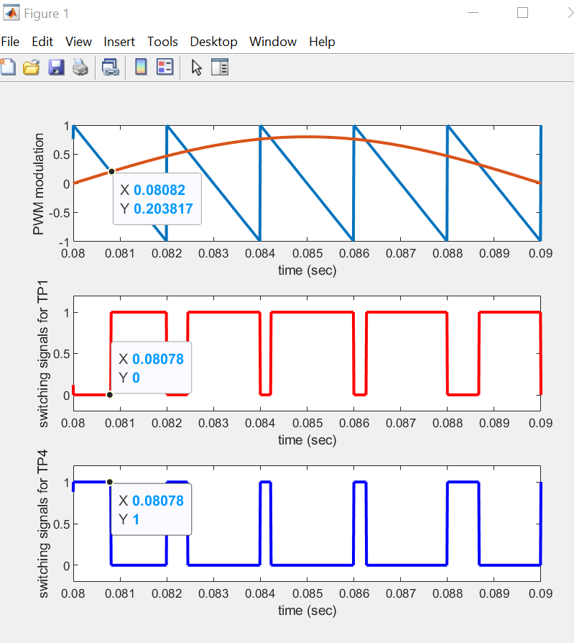

**Observation for PWM plot:** The carrier triangular waveform has an amplitude of 1 and the sine waveoform has a amplitude of 0.8. Since the triangualr wave has a frequency of 500Hz, its period T = 1/500 = 0.002s. It can be seen from the graph that the triangular wave repeats itself at every 0.002s. The sine wave has a frequency of 50Hz, its period T = 1/50 = 0.02s. From the graph, we can see the sine wave completed half a cycle from 0.08s to 0.09s.

When the carrier triangular waveform is greater than the sine waveform, TP1 is 0 (off) and TP4 is 1 (on). Likewise, when the sine waveform is greater than the triangular waveform, TP1 is 1 (on) and TP4 is off (o). The points when the triangular wave intersects with the sine wave provide the signal for TP1 and TP4 to turn on or off respectively, ie: the point of intersections of the two waveform provide the switching instants of the power semiconductor decices. For example, from 0.08s to 0.081s the triangular waveform is greater than the sinuiduol waveform hence TP1 is 0 and TP4 is 1 from 0.8s to 0.081s. At the point of intersection, TP1 and TP4 flipped. From 0.081s to 0.082s the triangular waveform is smaller than the sinudoul waveform, hence TP1 is 1 and TP4 is 0.

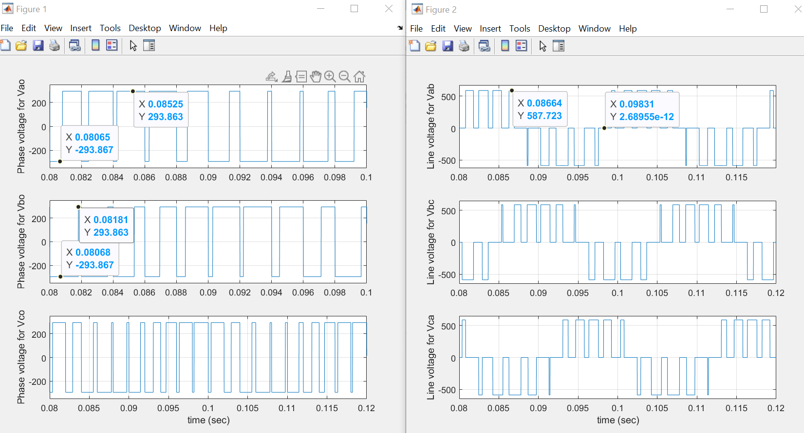

**Observations for Vao:** If the triangular waveform is greater than the sinuodol waveform, Vao will be -293V. If the sine wave is greater than the triangular wave, Vao will be +293V. For example, from 0.08s to 0.081s Vao is negative at -293V. This is because the triangular waveform is greater than the sinuidol waveform and TP1 is 0 and TP4 is 1 from 0.08s to 0.081s. From 0.081s to 0.082s Vao is positive at 293V as seen in the graph. This is because, TP1 is 1 and TP4 is 0 and the triangular waveform is greater than the sinuidol waveform. The pulse width of Vao gets thicker and thicker from 0.08s to 0.088s when the sine wave goes from 0° to 90°. After 0.088s to 0.093s the pulse width of Vao gets smaller and smaller as the sine wave goes from 90° to 180° as seen in the PWM plot.

**Observations for Vab:**

Vab is derive from the equation **Vab = Vao – Vbo**. Vab has a maximum voltage of 586V and a mimium voltage of -586V.

From 0.08s to 0.081s Vao is -293V while Vbo is – 293V. Hence from 0.08s to 0.081s Vab = -293+293 = 0V. From 0.081s to 0.082s Vao = 293V while Vbo = 293V hence Vab = 293 + 293 = 586V. This cycle repeats for the postive half cycle of the sine wave and Vab will flip when the sine wave is in the negative half cycle.

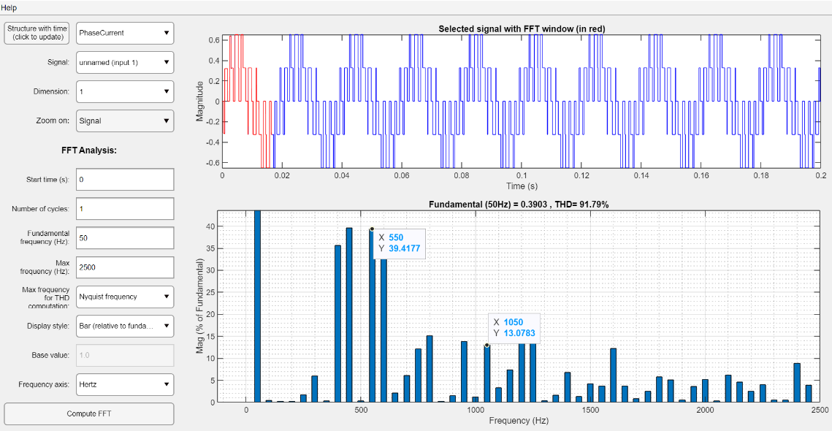

**Observations for FTT:**

Harmonics is present and is in every odd multiple of the carrier frequency, **𝑓h = 𝐾𝑓𝑐 ± 𝑘𝑓**. The carrier frequency would shift the harmonics to a higher frequency. Since the carrier frequency = 500Hz and fundamental frequency = 50 Hz, the first harmonics observed is fh = 500 **±** 50 = 550Hz or 450Hz. The next harmonics would be fh = 1000 **±** 50 = 950Hz or 1050Hz. The harmonics would be at an interval of every 500Hz.

2. Only change the frequency in the block of carrier waveform to 2 kHz and observe the difference in the switching signals, and the line voltage *Vao,* and *Vab* in the scope.

**Use the Matlab file ‘PWMplot.m’ to understand the working principles of PWM modulation. Use the Matlab file ‘inverterplot.m’ to observe the phase and line voltages *Vao* and *Vab*. Use the ‘powergui’ block in the Matlab simulation model to check FFT of the current for phase-*a*.**

Use the “PWMinverter_b.slx” file for executing the Simulink program.

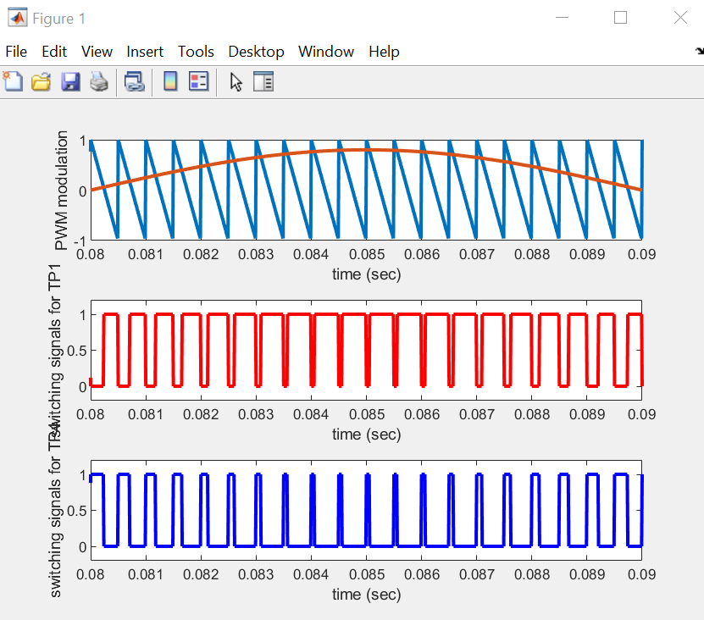

**Observation for PWM plot:**

The carrier triangular waveform has an amplitude of 1 and the sinuidoul waveoform has a amplitude of 0.8. Since the triangualr wave has a frequency of 2000Hz, its period T = 1/2000 = 0.0005s. It can be seen that the triangular wave repeats itself at every 0.0005s. The sine wave has a frequency of 50Hz, hence its period T = 1/50 = 0.02s. It can be seen that the sine wave completed half a cycle from 0.08 to 0.09.

When the carrier triangular waveform is greater than the sinuidoul waveform, TP1 is 0 (off) and TP4 is 1 (on). Likewise, when the sinudoul waveform is greater than the triangular waveform, TP1 is 1 (on) and TP4 is off (o). The points when the triangular wave intersects with the sinusoidal wave provide the signal for TP1 and TP4 to turn on or off respectively, ie: the point of intersections of the two waveform provide the switching instants of TP1 and TP4. **Similar observations is explained above** just that in this case TP1 and TP4 switches on and off more frequently due to the higher frequency of the triangular wave as the frequency increases from 500 Hz to 2000 Hz.

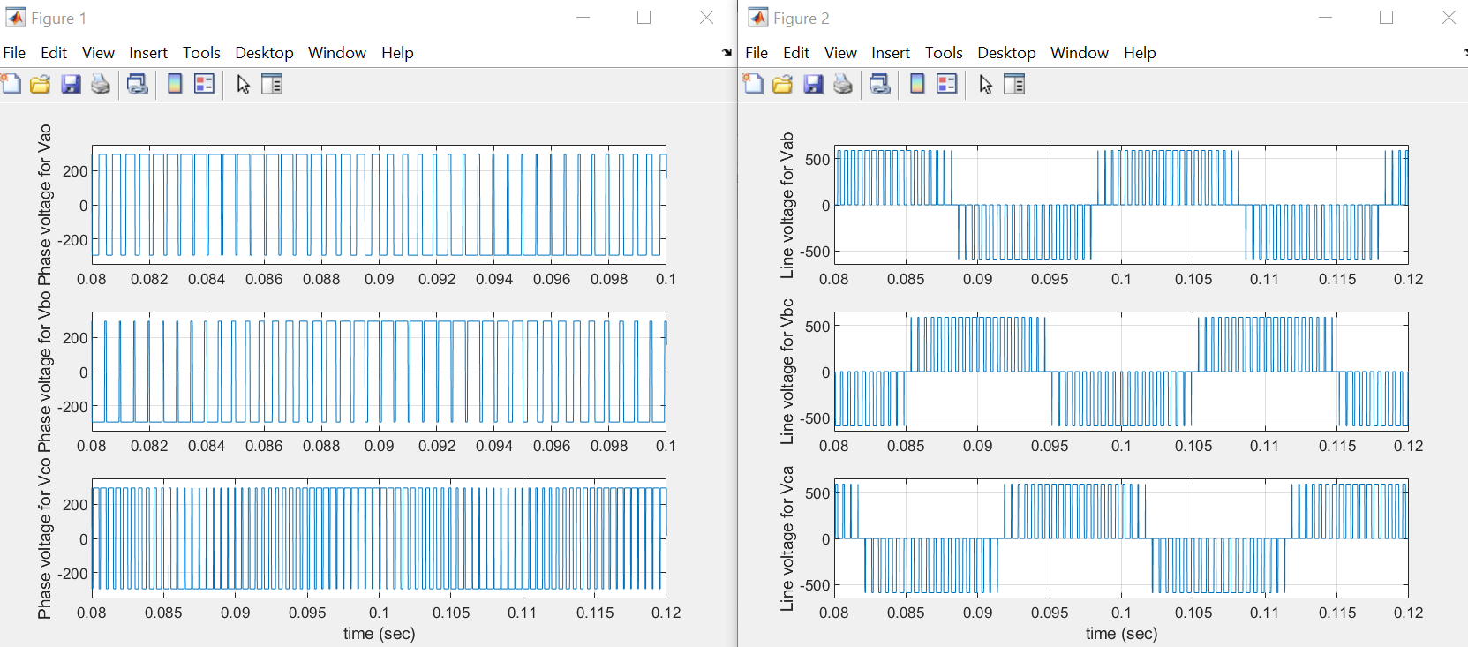

**Observations for Vao:** The maximum and minimum voltage of Vao remains unchanged at -293V and +293V respectively. **Similar observation is obsevered as mentioned above** however in this case, the pulse width is smaller and it has a shorter time interval and due to the increase in carrier frequency.

**Observations for Vab:** Vab is derive from the equation **Vab = Vao – Vbo**. **Similar observation is obsevered as mentioned above** but the pulse of Vab is much smaller with shorter time interval due to the increase in carrier frequency.

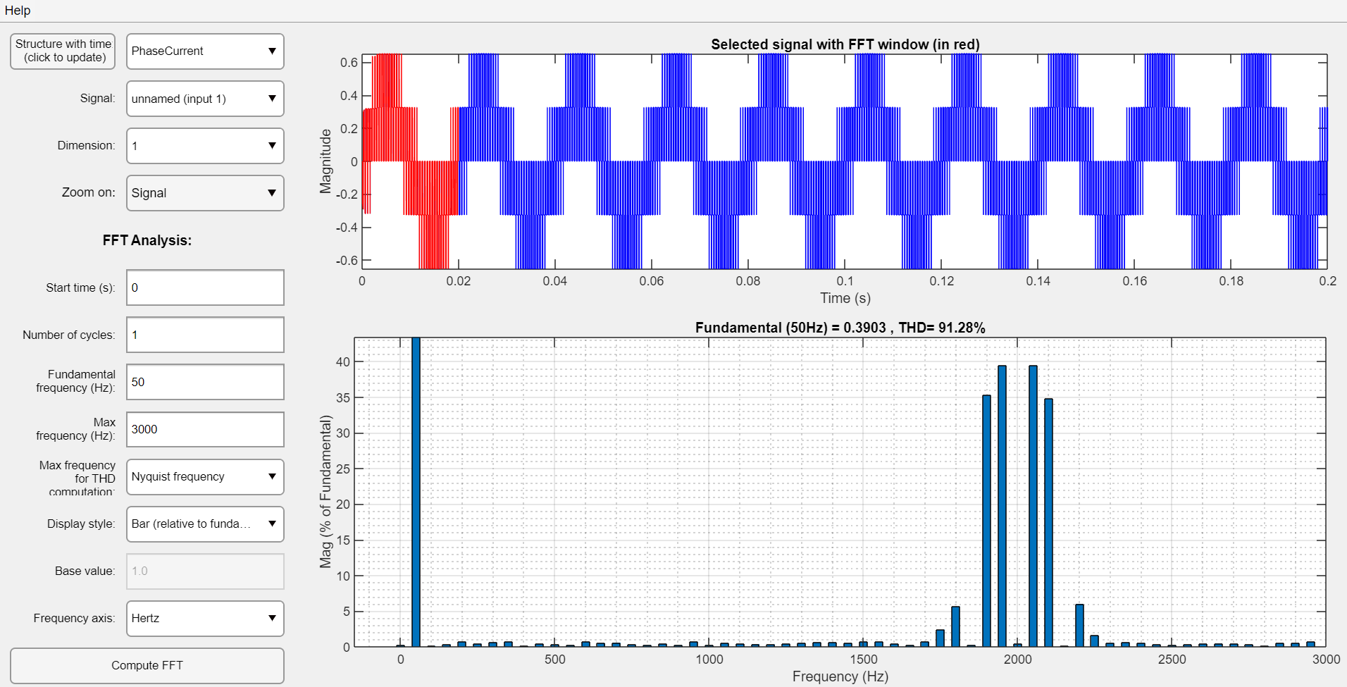

**Observations for FTT:**

Harmonics is present and is in every odd multiple of the carrier frequency, **𝑓h = 𝐾𝑓𝑐 ± 𝑘𝑓**. The carrier frequency would shift the harmonics to a higher frequency. Since the carrier frequency = 2000Hz and fundamental frequency = 50 Hz, the first harmonics observed is fh = 2000 **±** 50 = 1950Hz or 2050Hz. The harmonics would be at an interval of every 2000Hz.

3. Now place inductors (e.g. 1.6 H) in series with the resistive load for each phase. Then observe and discuss the voltage and current waveforms across the resistance.

**Use the ‘powergui’ block in the Matlab simulation model to check FFT of the current signal in phase-a. Use the Matlab file ‘inverterplot.m’ to observe the voltage and current across the resistance.**

Use the “PWMinverter_c.slx” file for executing the Simulink program.

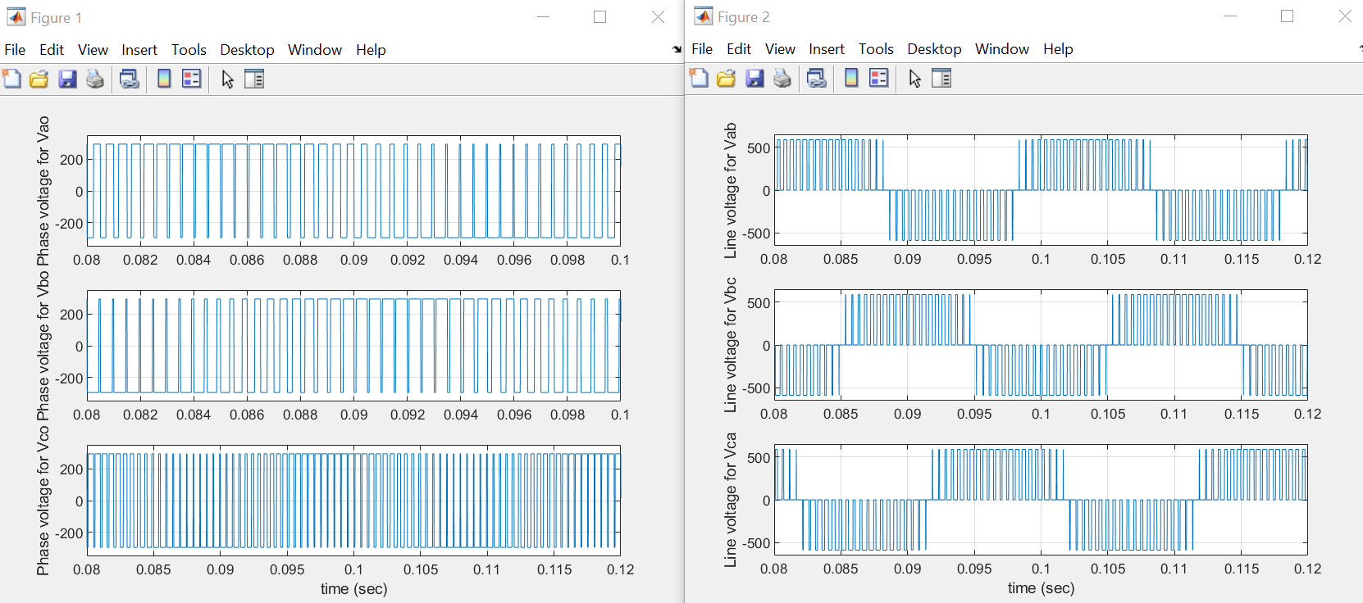

**Observations for Vao and Vab:**  The graph of Vao and Vab is the same as the previous graph as the addtion of inductor does not have any affect on Vao and Vab.

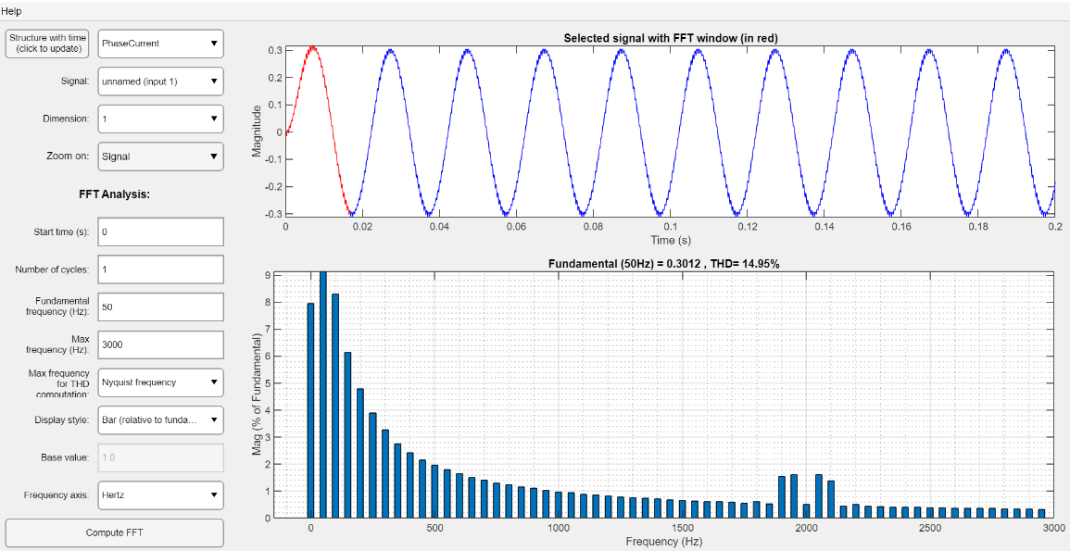

**Observations for FTT:**

It can be seen that adding inductor to the system reduces harmonics. The THD 14.95% which is lower than before indicating lesser loss in the system. Also, adding inductor into the circuit causes the frequency of the harmonics to be filter out resulting the current waveform to be like a sinusoidal waveform as seen above.

4. Change the amplitude of the reference signals for phase *a*, *b*, *c* to 0.5, and the frequency of the reference signals for phase *a*, *b*, *c* to 100 Hz. Observe and explain the voltage and current waveforms across the resistance.

**Use the ‘powergui’ block in the Matlab simulation model to check FFT of the current signal in phase-a. Use the Matlab file ‘inverterplot.m’ to observe the voltage and current across the resistance.**

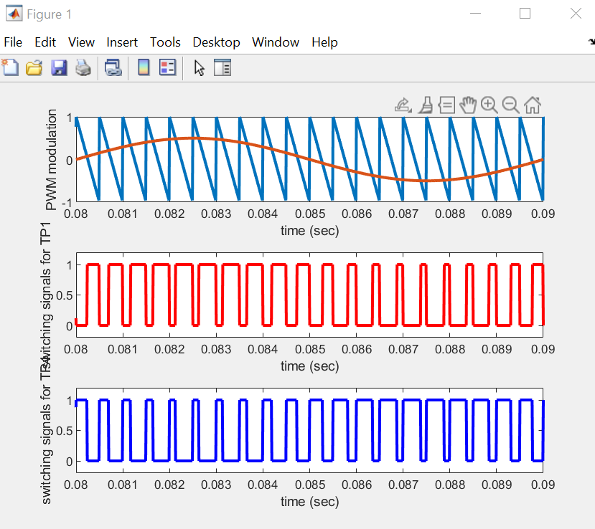

**Observation for PWM plot:**

The carrier triangular waveform has an amplitude of 1 and the sinuidoul waveoform has a amplitude of 0.5. Since the triangualr wave has a frequency of 2000Hz, its period T = 1/2000 = 0.0005s. It can be seen that the triangular wave repeats itself at every 0.0005s. The sine wave has a frequency of 100Hz, hence its period T = 1/100 = 0.01s. It can be seen that the sine wave completed a full cycle from 0.08 to 0.09.

When the carrier triangular waveform is greater than the sinuidoul waveform, TP1 is 0 (off) and TP4 is 1 (on). Likewise, when the sinudoul waveform is greater than the triangular waveform, TP1 is 1 (on) and TP4 is off (o). The points when the triangular wave intersects with the sinusoidal wave provide the signal for TP1 and TP4 to turn on or off respectively, ie: the point of intersections of the two waveform provide the switching instants of TP1 and TP4. **Similar observations is explained above** just that in this case TP1 and TP4 switches on and off more frequently due to the higher frequency of the triangular wave and sine wave.

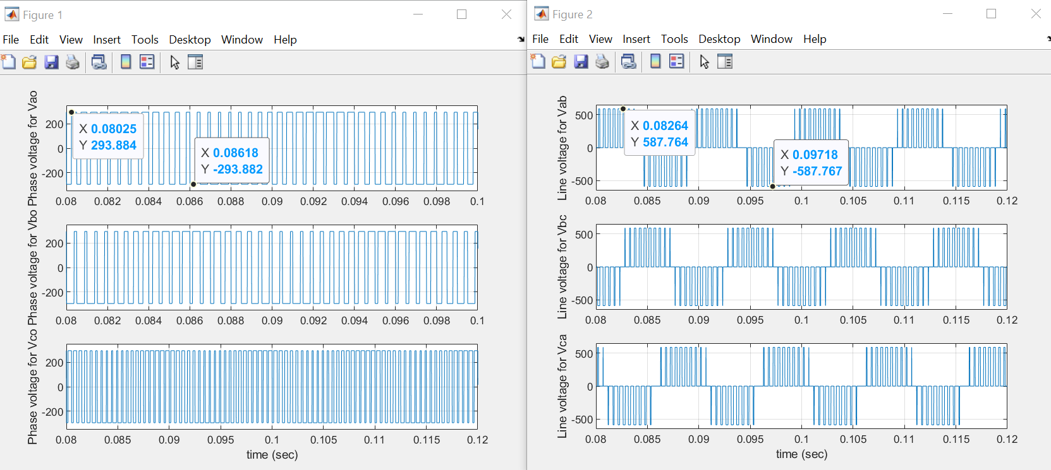

**Observations for Vao:** The maximum and minimum voltage of Vao remains unchanged at -293V and +293V respectively. **Similar observation is obsevered as mentioned above** however in this case, the pulse width is smaller and it has a shorter time interval and due to the increase in carrier frequency and increase in frequency of the sine wave.

**Observations for Vab:** Vab is derive from the equation **Vab = Vao – Vbo**. **Similar observation is obsevered as mentioned above** but the pulse of Vab is much smaller with shorter time interval due to the increase in carrier frequency. There is also more cycle of Vab for a given time as the frequency of sine wave and triangular wave increases.

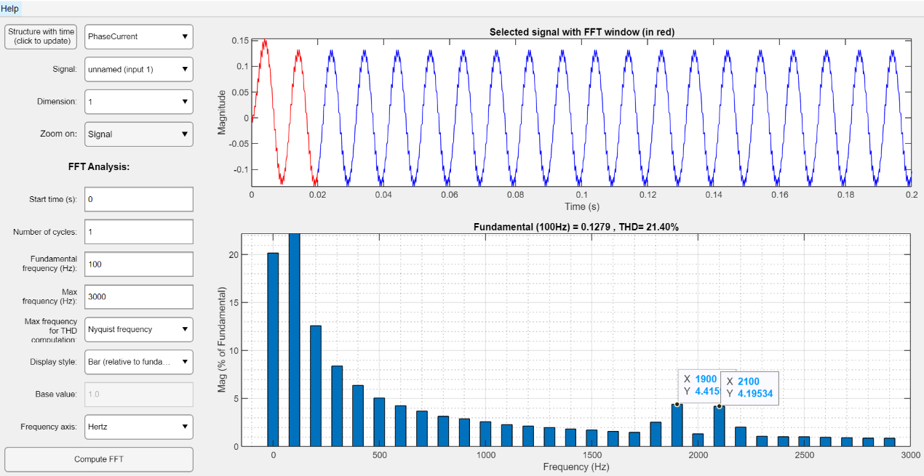

**Observations for FTT:**

It has similar shape as the previous graph, however the frequency of the harmonics changes as frequency of the reference signal changes. The carrier ratio, **p = fc/f** has been reduced as the frequency of the reference signals have been increased from 50Hz to 100Hz. fh = 2000 **±** 100 = 1900 or 2100 Hz. As such, the frequency of the harmonics, fh will be at 1900Hz or 2100Hz. Modulation index, m = A/Am also increases as Am decreases from 0.8 to 0.5.

A large carrier ratio causes the harmonics to be easily filtered out by the machine leakage inductance which result in a near sinusoidal current waveform. THD is at 21.4%.

**Simulation 2: Introduction to *v/f* control of induction motor**

Use the “acmotor_vf.mdl” file for executing the Simulink program. In this exercise, you would study the forward motoring and forward braking of an ac motor. Subsequently, the performance of the *v/f* control for ac motor drive system under step-change in reference speed or step-change in load-torque command could be examined.

1. Set the speed reference to the values of 300, 900, 1500 rpm respectively. For each setting, record the data of the frequency and amplitude of the motor input voltage, the value of the field flux and the speed at steady state. Plot the graph of the ‘*v* – *f*’ plot and explain how *v/f* control scheme works.

**Use the Matlab file ‘vfplot.m’ in the Matlab window to observe the performance of the v/f control of the motor.**

For 300 rpm: 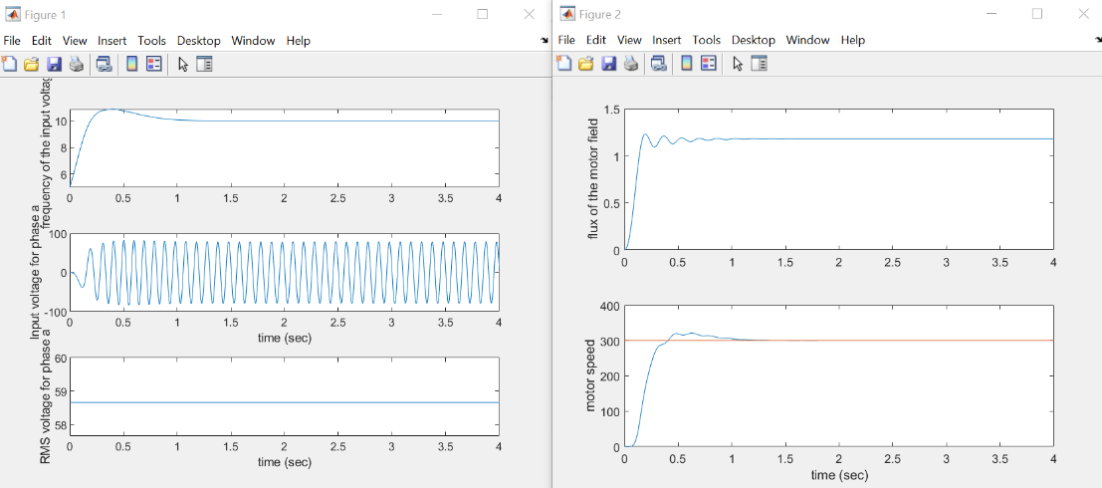

We observed that the flux on the motor field is constant when t = 1s when the motor reaches constant speed of 300 rpm. Likewise, the voltage is always constant at 58.6V while frequency is constant at 10.8Hz after t = 1s.

For 900 rpm:

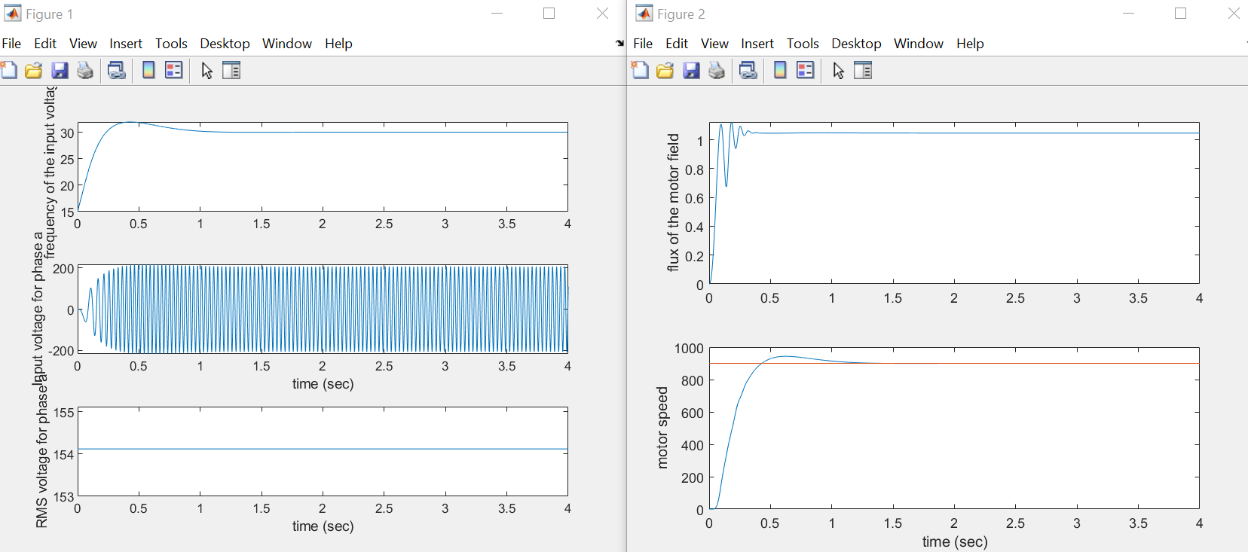

We observed that the flux on the motor field is constant when t = 1s when the motor reaches constant speed of 900 rpm. Likewise, the voltage is always constant at 154.1V while frequency is constant at 31.9Hz after t = 1s.

For 1500 rpm:

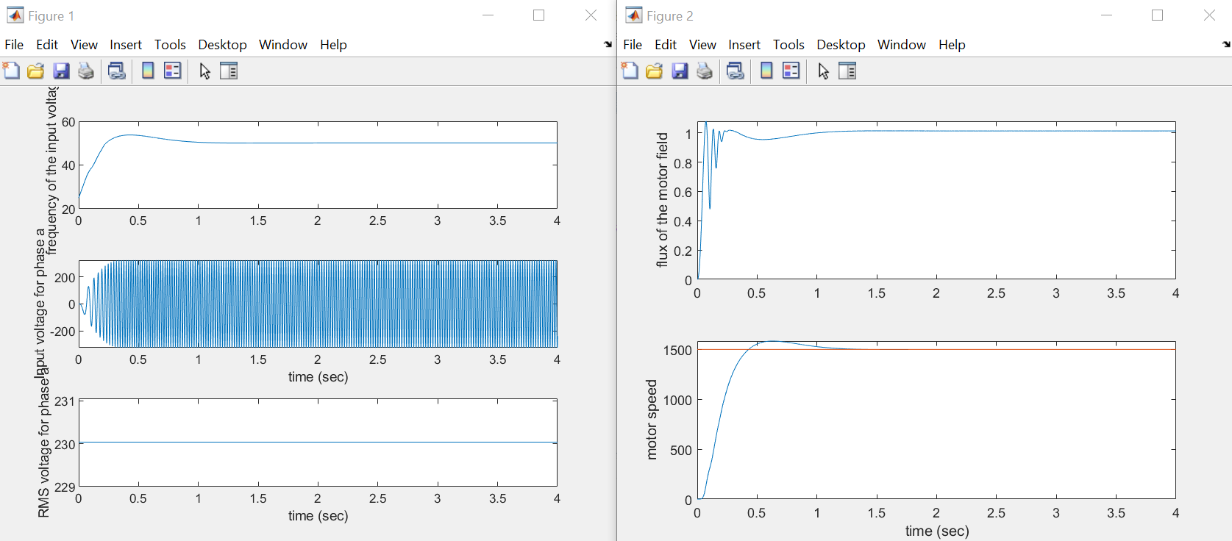

We observed that the flux on the motor field is constant after t = 1s when the motor reaches constant speed of 1500 rpm. Likewise, the voltage is always constant at 230V while frequency is constant at 53.7Hz after t = 1s.

|  |  |  |
| --- | --- | --- |
| Speed / rpm | Voltage / V | Frequency, f / Hz |
| 300 | 58.6 | 10.8 |
| 900 | 154.1 | 31.9 |
| 1400 | 230.0 | 49.8 |
| 1500 | 230.0 | 53.7 |
| 1600 | 230.0 | 58.8 |

We take several additional readings over a range of speed (1400 rpm and 1600 rpm). We observed that at 1400 rpm, frequency is near 50Hz and the voltage is already at a maximum at 230V. This indicates that v/f ratio cannot be kept constant at speed above 1400 rpm and the motor is operating in the weaking field-flux region.

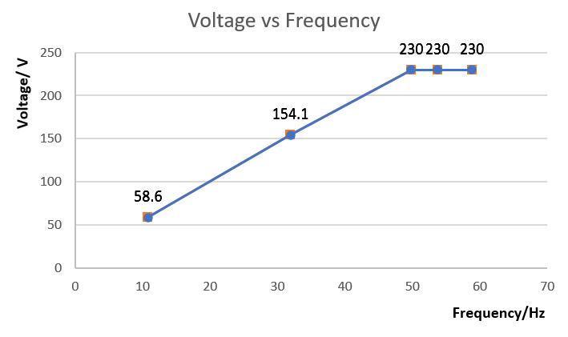

The voltage, frequency and flux is related by this equation:

**V = 4.44(fs)(flux)(N)(Kw)**, where fs is supplied frequency, N = number of turns, Kw is winding factor.

Based on the equation, if fs is reduced while V remains constant, flux will increase which result in higher core losses which is not ideal. Also, if fs increased then flux would have to decrease to keep Voltage constant which will reduce the torque produced by the motor which is not ideal. Hence the v/f ratio is kept constant so that flux can be kept constant in the machine to prevent the scenarios mentioned above from happening. The Voltage vs frequency curve has a constant gradient (from 10Hz to 50Hz) as V/f ratio is kept constant. However, above rated voltage, v/f ratio cannot be kept constant anymore as the voltage cannot exceed its rated voltage due to supply side constraint. Above rated voltage, the machine will operate in field weaking mode as v/f ratio will decrease, resulting in flux to decrease. The voltage-frequency graph is a horizontal line when it reaches maximum voltage of 230V.

1. Investigate the performance of the drive system when the reference speed is step-changed from 1500 rpm to 1200 rpm at *t* = 2 sec and from 1200 rpm to 900 rpm at *t* = 3 sec. Please note that no external mechanical load is applied.

**Use the Matlab file ‘wTplot.m’ in the Matlab window to observe the motor drive system response to the speed step-change and identify the forward motoring and forward braking operation.**

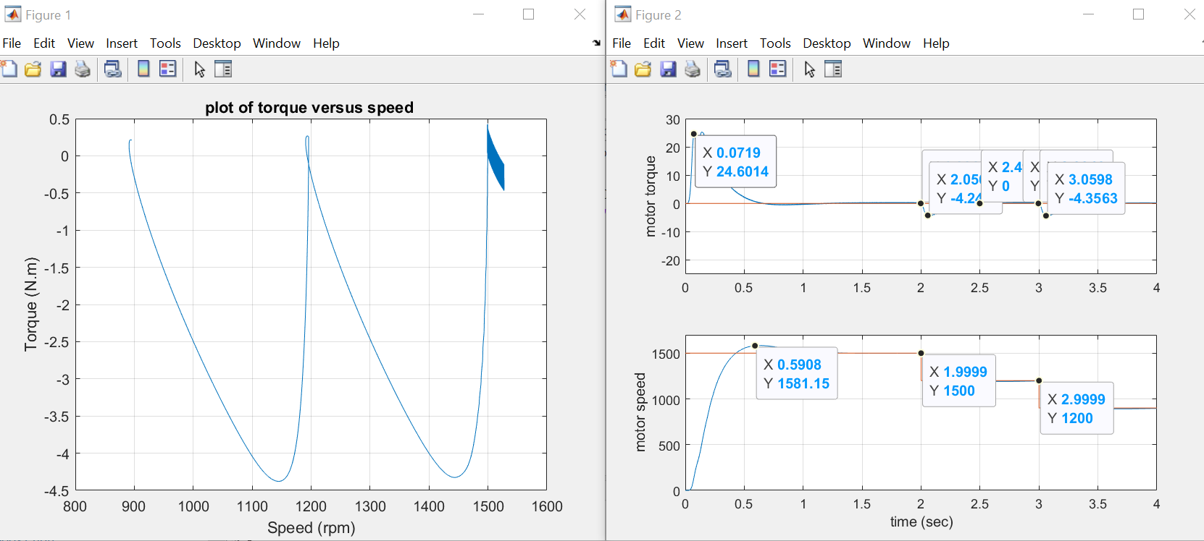

**Explanation for forward motoring and braking region:**

From t = 0s to t = 1s, the motor torque increases from 0 N.m to 24.6 N.m and decreases back to 0 N.m. The motor speed increases from 0 rpm to 1500 rpm. Since the motor torque is positive and motor speed is positive, the motor operates in forward motoring (quadrant 1) during this time.

From t = 2s to t = 2.5s, motor torque decreases from 0 N.m to -4.3 N.m and goes back to 0 N.m within this time frame. Motor speed decreases from 1500 rpm to 1200 rpm but is still positive. The motor torque is negative while motor speed is positive. Hence the motor operates in the forward braking operation (quadrant 2).

From t = 3s to t = 3.5s, motor torque decreases from 0 N.m to -4.3 N.m and goes back to 0 N.m within this time frame. Motor speed decreases from 1200 rpm to 900 rpm but is still positive. The motor torque is negative while motor speed is positive. Hence the motor operates in the forward braking operation (quadrant 2).

1. Investigate the performance of the drive system when the load torque is step-changed from 0 to 5 N.m at *t* = 2 sec. Please note that the reference speed is kept constant at 1000 rpm.

**Use the Matlab file ‘wTplot.m’ in the Matlab window to observe the motor drive system response to the speed step-change and identify the forward motoring and forward braking operations.**

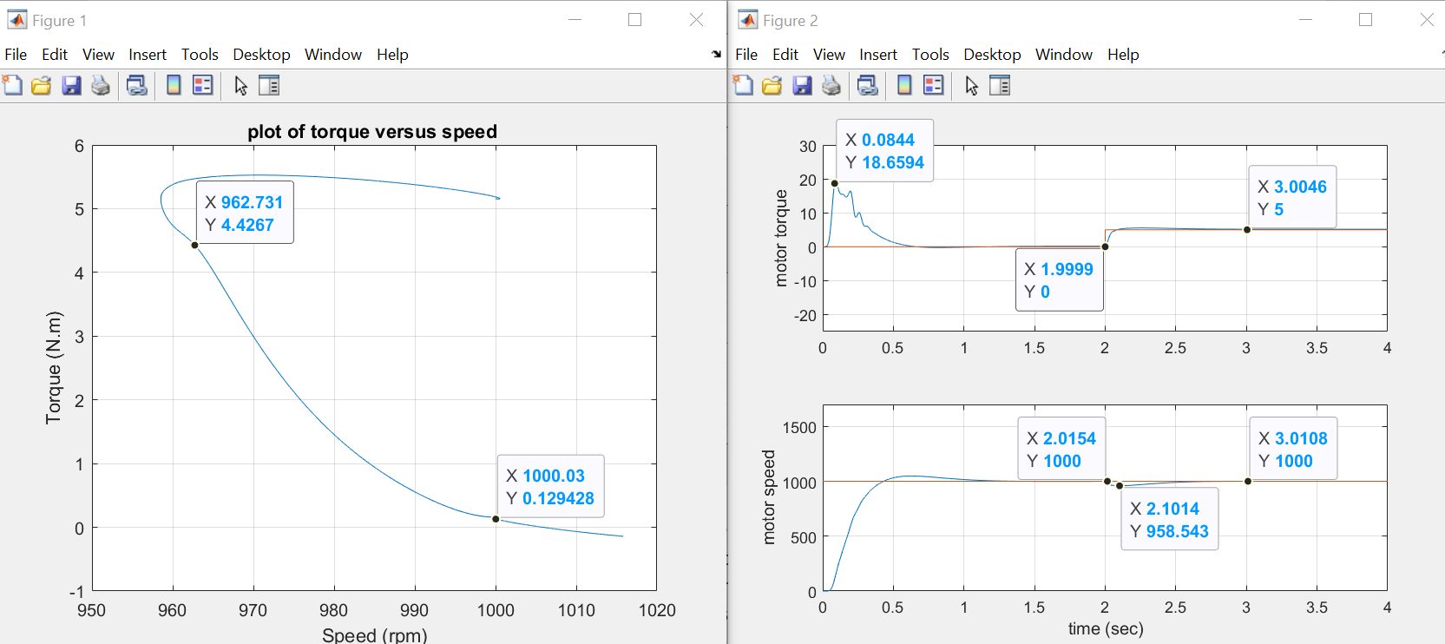

From t = 0s to t = 1s, motor torque increases from 0 N.m to 18 N.m and back to 0 N.m within this time frame and motor speeed increases from 0 rpm to 1000 rpm. Hence motor torque and motor speed is both positive as the machine is operating in forward motoring region (quadrant 1).

From t = 2s to t =2.5s, motor torque increases from 0 N.m to 5 N.m as the load torque increases from 0 to 5 N.m. The speed of the motor decreases from 1000 rpm to 958 rpm and slowly goes back to 1000 rpm. Since motor torque and motor speed are positive, they operate forward motoring region.

The speed of the motor has to decrease at t = 2s as . Since Tl increases to 5N.m at t = 2s, motor speed Wm will decrease based on the equation shown above. The motor speed will eventually go back to 1000 rpm as it is a close loop system and it is set to run at 1000 rpm, however, instantaneously at t =2s, motor speed will decrease as shown on the graph above. Motor speed decreases from 1000 rpm at t = 2s to 958 rpm at t = 2.1s. After t =2.1s, motor speed increases back to 1000rpm.

After t =2s, the motor torque will be 5 N.m as **𝑇𝑚 = 𝑇𝑙 +𝐽dwm/dt.** At t=2s, motor load increases from 0 N.m to 5 N.m. When the speed of the motor remains constant at 1000 rpm,𝐽dwm/dt = 0 (The rate of change of speed is zero at constant speed of 1000 rpm) and therefore Tm =Tl. Hence Tm = 5N.m when speed is not changing and remains constant at 1000 rpm.

**Experiments:**

* + Experiment 1: Introduction to DC-to-AC conversion using pulse width modulation (PWM) inverter
  + Experiment 2: Introduction to *v/f* control of squirrel-cage induction motor
* **Equipment**
  + Power Supply (8821-2A)
  + Prime Mover/Dynamometer (8960-15)
  + Four-Pole Squirrel-Cage Induction Motor (8221-0A)
  + Vector-Control Drive Converter (9013-1A)
  + Resistive Load (8311-0A)
  + Smoothing Inductor (8325-15)
  + Current/Voltage Isolator (9056-15) – 2 sets

with ±15V/+5V Power Supply (8840-0A)

* + AC Voltmeter - (8426-05)
  + 4-Channel Oscilloscope

**CAUTION!**

**High voltages are present in this laboratory exercise! Do not make or modify any banana jack connections with the power on unless otherwise specified.**

**Experiment 1: Introduction to DC-to-AC conversion using pulse width modulation (PWM) inverter**

***1-A Torque versus Speed Graph of the Squirrel-Cage Induction Motor***

1. Set up the circuit as shown in Figure 4.
2. **Verify the circuit connection with lab assistants before turning on Power Supply**. Switch on the Power supply, set the 24 V-AC power switch to the marked I (on) position.
3. Set the Prime Mover/Dynamometer controls as follows:

– MODE switch: DYN.

– LOAD CONTROL MODE switch: MAN.

– MANUAL LOAD CONTROL knob: MIN. (fully CCW)

– DISPLAY switch: SPEED (rpm)

1. Set the Oscilloscope as follows:

– Ch1: 1V/DIV

– Ch2: 5V/DIV

– Time: 20s/DIV

– DISPLAY: X-Y



Figure.4: Circuit used to determine the torque versus speed characteristics

1. Turn on the Power Supply by setting its main power switch to the marked I (on) position and set voltage control knob to reach the motor rated speed.
2. On the Dynamometer, adjust the DISPLAY switch so that the torque indicated on the Dynamometer display. Use the MANUAL LOAD CONTROL knob to increase the load torque by increments of approximately 0.3N.m starting from 0 to MAX. For each torque setting, wait a few seconds for the motor speed to stabilize, and then record the motor speed. Try to capture the graph of the speed versus torque characteristics on the oscilloscope.
3. When all data has been recorded, set the MANUAL LOAD CONTROL knob on the Prime Mover/Dynamometer to the MIN. position, and set the main switch on the power supply to the marked **O** (off) position.

*Take note*

**Q1:** **In your report, plot the graph of motor torque versus motor speed by using the measured data. Compare the curve of the torque (*T*) as a function of the speed (*n*) plotted to the theoretical result.**

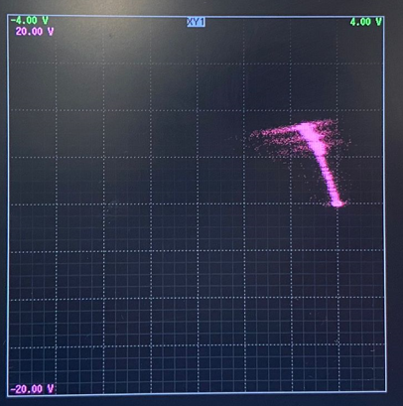

|  |  |  |  |  |  |  |  |  |  |  |
| --- | --- | --- | --- | --- | --- | --- | --- | --- | --- | --- |
| Torque/N.m | 0 | 0.3 | 0.6 | 0.9 | 1.2 | 1.5 | 1.8 | 2.1 | 2.4 | 2.7 |
| Speed / rpm | 1446 | 1450 | 1425 | 1396 | 1360 | 1318 | 1272 | 1208 | 1110 | 1022 |

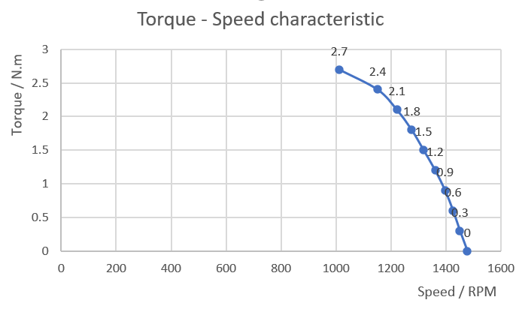

x-axis: speed in rpm, y-axis: torque in N.m

The two graph looks similar to each other.

From the graph above, we observed that as the torque increases, speed decreeases. This is because **Pout = Tm x Wm,** assume output power remains constant, hence if Torque increases, speed have to decrease, vice versa.

The graph has a constant gradient from 0 N.m to 2.4 N.m, hence speed torque characteristic is linear from 0 N.m to 2.4 N.m. However, we observed that pull out torque is 2.4 N.m as when torque exceeds 2.4 N.m, the speed-torque characteristic is non-linear.

**Experiment 2: Introduction to *v/f* Control of Squirrel-Cage Induction Motor**

***2-A Open Loop v/f Control of the Squirrel-Cage Induction Motor***

1. Use the vector control drive converter module and connect the Four-Pole Squirrel-Cage Induction Motor. Set up the circuit shown in Figure.5.
2. **Verify the circuit connection with lab assistants before turning on Power Supply**. Switch on the Power supply, set the 24V-AC power switch to the marked I (on) position.



Figure.5: Connection diagram for the ac drive of a squirrel-cage induction motor operating in open loop

1. On the computer, start the **Drive Wizard application (use admin login (only Mr. Chandra’s))**. Turn on the Power Supply by setting its main power switch to the marked **I** (on) position and set voltage control knob at 100%.
2. Click the ***Connect to inverter*** button in the toolbar of the Drive Wizard window. The *Manual Connection* dialog box should appear with “F7”.
3. Choose the ***File*** menu of the Drive Wizard window. This opens the *Open* dialog box. Select file **OPEN.PARMS** in the dialog box and Click the ***Load***button to load the file in the computer memory. Click the **Inverter *Write all parameter values*** button in the toolbar of the Drive Wizard window. The *Download Options* dialog box should appear. Click the *OK* button to close this dialog box.
4. Press the ***Enable***button to connect the computer and the Vector-Control Drive Converter. Set the reference speed at 5 Hz and press button to give the gate switch signals of the Inverter.
5. This file will run the motor at 20Hz as the reference speed.

*Take note*

**Q2:** **Vary the input frequency of the motor by varying the frequency reference of the Vector-control Drive Converter. Using the computer, set the frequency reference to the values such as 5, 10, 20, 30, 40, 50, 60 Hz. (Don’t speed up the motor suddenly.) For each frequency, record the data of the motor input voltage V2 and steady state speed. In your report, plot the graph of the input voltage of motor-the reference frequency and explain how v/f control scheme work?**

1. When all data has been recorded depress the key.

We can calculate Ns, synchronous speed of the machine by using this formula,

Ns = 120fs/p. Where the number of poles is 4 poles and fs is supplied frequency.

For example, when fs = 5Hz, Ns = (120 x 5) / 4 = 150 rpm.

|  |  |  |  |  |  |  |  |
| --- | --- | --- | --- | --- | --- | --- | --- |
| Frequency/ Hz | 5 | 10 | 20 | 30 | 40 | 50 | 60 |
| Voltage / V | 50 | 70 | 120 | 160 | 200 | 240 | 240 |
| Motor speed / rpm | 121 | 260 | 535 | 815 | 1100 | 1387 | 1615 |
| Synchronous speed / rpm | 150 | 300 | 600 | 900 | 1200 | 1500 | 1800 |

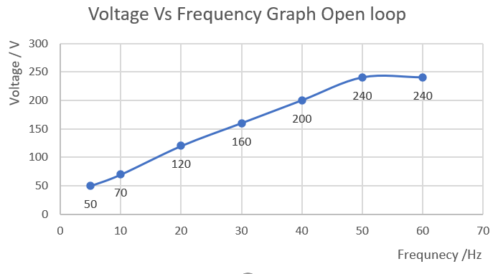

The voltage, frequency and flux is related by this equation:

**V = 4.44(fs)(flux)(N)(Kw)**, where fs is supplied frequency, N = number of turns, Kw is winding factor.

Based on the equation, if fs is reduced while V remains constant, flux will increase which result in higher core losses which is not ideal. Also, if fs increased then flux would have to decrease to keep Voltage constant which will reduce the torque produced by the motor which is not ideal. Hence the v/f ratio is kept constant so that flux can be kept constant in the machine to prevent the scenarios mentioned above from happening. The Voltage vs frequency curve has a constant gradient as V/f ratio is kept constant. However, above rated voltage, v/f ratio cannot be kept constant anymore as the voltage cannot exceed its rated voltage due to supply side constraint. Above rated voltage, the machine will operate in field weaking mode as v/f ratio will decrease, resulting in flux to decrease. In the v/f graph it can be seen that above rated voltage, the terminal voltage will remain constant due the supply limitation and the flux will decrease as the frequency increases.

***2-B Closed Loop v/f Control of the Squirrel-Cage Induction Motor***

1. Set up the circuit shown in Figure.6.
2. **Verify the circuit connection with lab assistants before turning on Power Supply**. Switch on the Power supply, set the 24V-AC power switch to the marked I (on) position.



Figure.6: Connection diagram for the ac drive of a squirrel-cage induction motor operating in close loop

1. Turn on the Power Supply by setting its main power switch to the marked **I** (on) position and set voltage control knob at 100%.
2. Using the Drive Wizard application, download file **CLOSE.PARMS** to run the motor at 5Hz as the reference speed.
3. This file will run the motor at 20 Hz as the reference speed.

*Take note*

**Q3:** **Vary the input frequency of the motor by varying the frequency reference of the Vector-control Drive Converter. Using the computer, set the frequency reference to the values such as 5, 10, 20, 30, 40, 50, 60 Hz. (Don’t speed up the motor suddenly.) For each frequency, record the data of the motor input voltage V2 and steady state speed. In your report, plot the graph of the input voltage of motor-the reference frequency and note the difference with the same of the previous run.**

1. When all data has been recorded depress the key.

|  |  |  |  |  |  |  |  |
| --- | --- | --- | --- | --- | --- | --- | --- |
| Frequency/ Hz | 5 | 10 | 20 | 30 | 40 | 50 | 60 |
| Voltage / V | 90 | 100 | 180 | 280 | 360 | 400 | 400 |
| Speed / rpm | 143 | 283 | 580 | 875 | 1175 | 1465 | 1750 |
| Synchronous speed / rpm | 150 | 300 | 600 | 900 | 1200 | 1500 | 1800 |

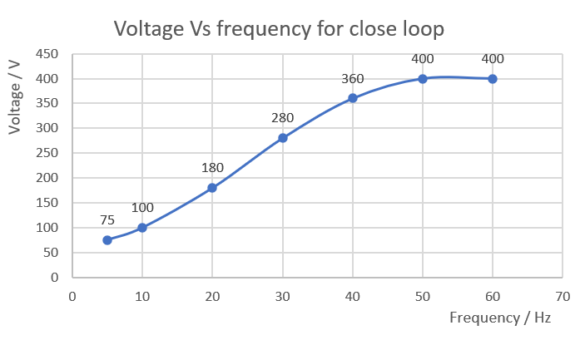

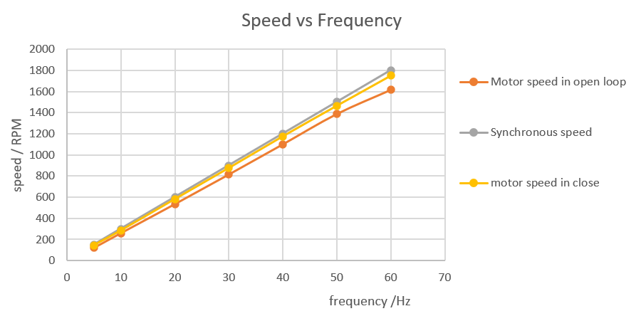

**Firgure 1: Speed of synchornous speed, motor speed in close and open loop**

Both v/f graph has simialr shape and above rated voltage, the v/f ratio cannot be kept constant. However, in the close loop control, we can see that there is voltage boosting. Hence the performance for the close loop control is better than the open loop as voltage boosting is present at lower frequencies.

In the v/f graph it can be seen that above rated voltage, the terminal voltage will remain constant due the supply limitation and the flux will decrease as the frequency increases.

Also, when we plot the motor speed in close loop, motor speed in open loop and the synchronous speed. From the graph, we obsevered that the motor speed for close loop is closer to synchronous speed than for the open loop as seen in the graph above. This is because there is voltage boosting and the presence of feedback in the close loop control which improve the performance of the motor allowing it to operate at higher speeds and also nearer to synchornous speed than open loop control.

**Take note:**

1. **As you will be working with high voltage, DO NOT come to the lab in slippers.**
2. **Please print out all the waveforms stated in the experiment.**
3. **Please tidy all the wires after finishing the experiments.**

**Please answer the following questions and attach the relevant waveforms in the report**

**Simulations:**

**Simulation 1: Introduction to PWM Inverter**

1-A. **500 Hz carrier frequency (R load)**

1. Attach the PWMplot.m wave forms
2. Attach voltage Vao and line voltage Vab waveforms
3. Attach the source current ‘Ia’ FFT analysis waveform, provide the THD obtained
4. Comment your observations

1-B. **2 kHz carrier frequency (R load)**

a. Attach the PWMplot.m wave forms

b. Attach voltage Vao and line voltage Vab waveforms

c. Attach the source current ‘Ia’ FFT analysis waveform, provide the THD obtained

d. Comment your observations

1-C. **2 kHz carrier waveform (R-L load)**

a. Attach voltage *Vao* and line voltage *Vab* waveforms

b. Attach the source current ‘*Ia’* FFT analysis waveform, provide the THD obtained

c. Comment your observations

1-D. **2kHz carrier waveform, amplitude of 0.5, 100 Hz frequency of reference waveform (R-L load)**

a. Attach the PWMplot.m wave forms

b. Attach voltage *Vao* and line voltage *Vab*waveforms

c. Attach the source current ‘*Ia*’ FFT analysis waveform and provide the THD obtained

d. Comment your observations

**Simulation 2: *v/f* control**

2-A. *v/f* control

* 1. Attach the waveforms from vfplot.m for one speed condition.
  2. Record the values of motor voltage and frequency of motor for different speed references and plot V - f curve using the recorded data and comment on how v/f control works.

2-B. Effect of change of speed with ‘no load torque’

1. Attach the waveforms from wTplot.m, identify the forward motoring and braking regions from torque speed characteristics and comment on your observations.

2-C. Effect of change of load torque with ‘constant speed’

1. Attach the waveforms from wTplot.m, identify the forward motoring and braking regions from torque speed characteristics and comment on your observations.

**Experiments:**

**Experiment 1: Introduction to DC-to-AC conversion using pulse width modulation (PWM) inverter**

1-A. Torque vs Speed Graph of the Induction Motor

1. Attach the printed waveform of torque and speed from oscilloscope
2. Answer Q1 and comment on your observation

**Experiment 2: Introduction to V/f Control of Squirrel-Cage Induction Motor**

2-A. Open Loop V/f Control

* 1. Answer Q2 and comment on your observation

2-B. Closed Loop V/f Control

1. Answer Q3 and comment on your observation